**2023上海国际餐饮设备及食品饮料博览会**

The 14th Shanghai International Exhibition for the Food,Drink,Hotel,Catering & Foodservice Industries 2023

**时间：2023年12月21日~23日 地点：中国·上海世博展览馆**

Date: December 21~23, 2023

网址/ Web：[www.wohcce.com](http://www.wohcce.com)

指导单位·Guidance unit

国际美食餐饮行业协会

International Association of Gastronomic and Catering Industries

中国食品工业协会冷冻冷藏食品专业委员会

Refrigerated and Frozen Foods Committee of China National Food Industry Association

亚洲国际餐饮协会丨Asian International Catering Association

世界酒店业联盟丨World Hotel Association

上海日用品行业协会丨Shanghai Commodity Association

主办单位·Hosted by

全国食文化联盟丨National Food Culture Alliance

日用品行业协会酒店用品专业委员会

Hotel Supplies Commission of Shanghai Commodity Association

中国315诚信品牌企业联盟食品安全诚信工作委员会

中国餐饮协会丨China Catering Association

上海展窑展览服务有限公司Shanghai Kilnexpo Exhibition Service Co.,Ltd.

协办单位·Co-organizer by

江苏省餐饮行业协会丨Jiangsu Province Dining Profession Association

广东省餐饮服务行业协会丨GuangDong Restaurant Association

山东省厨具协会丨Shandong kitchen utensils Association

上海市食品学会丨Shanghai Society of Food Science

支持单位·Supported by

越南渔业水产协会丨Vietnam fisheries and Fisheries Association

澳洲肉类及畜牧行业协会丨Australian Meat and Livestock Industry Association

浙江省酒店用品协会丨Zhejiang Hotel Supplies Association

上海进口食品协会丨Shanghai Import Food Association

中国冻品联盟丨China Frozen Foods Alliance

中国国际厨师协会丨Chinese International Chefs Association

浙江燃气具和厨具行业协会丨Zhejiang Gas Appliances and Kitchenware Industry Association

山东省食文化研究会丨Shandong Society of Food Culture

各地食品工业协会丨All places of China National Food Industry Association

全国旅游饭店业与餐饮协会丨National association of Turist Hotel and Restaurant

各地食文化研究会、全国食品企业联盟

2023年预计数据

1600+中外品牌参展、10万+展览面积、11万+专业观众，

20+论坛及赛事活动、意向成交额69.32亿元；

上海万润国际酒店用品市场、宁夏商务厅展团、马来西亚展团、黑龙江省展团、美国冷王、蓝威斯顿、泰国Boonyakeat、正大食品、太太乐、九曳供应链、上海卓美、创历制冷、酒食酒、赛卓、东玉玻璃、赛特冷链、浙江永创、西克制冷、安鲜达、酸辣粉、广东乡谷村、味泰供应链、千味央厨、爱焙乐、上海酒总、惊石农业、江苏裕灌、广东珠江桥、海圣生物、每天果、集泰食品、爱杯、冷联天下、大连盖世、联源机械、浙江碧海仙、华欧、欣发食品、凌云思、钰彩包装、永乐食品、好侍食品、传奇陶瓷、上海太易、九阳、仲景、微盟、浙江绿力、宝格玛、海南椰国、群昌智能、长膳智能、普缇茶业、良基、莱奥制冷、大华金属、集美、万得弗等

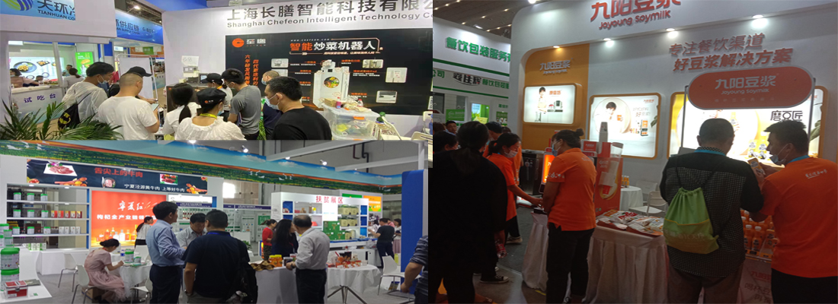

同期举行·Alongside

咖啡与茶、饮料与酒、食品食材、水产及冷链、连锁加盟、中央厨房、餐饮用品和加工机械八大主题系列专区，酒店及餐饮业一站式采购平台。

Coffee and tea, beverage and wine, food and catering, seafood and cold chain, chain franchise, central kitchen, consumables and processing machinery eight thematic series of special areas, Hotel and catering industry one-stop procurement platform.

**■展会概况**·**Exhibition Overview：**

中国消费者越来越注重地道和独特的食品和饮料。近年来，中国消费者对在国内市场采购到与进口食品一样的高质量产品的需求渴望日益显著。2022年我国食品进口总额达到1390.9亿美元、同比增长2.9%，进口食品正在成为老百姓餐桌不可或缺的角色。中国饮料行业的体量超过万亿，预计2022年的增速在3%。2022年我国餐饮行业收入为4.39万亿元。2022年中国休闲食品行业市场规模为11654亿元。

伴随着全球食品餐饮行业的迅猛发展，带动了餐饮设备制造业的快速发展。预计，全球商业餐饮设备市场规模将在2025年达到1125亿美元。中国商用餐饮设备性价比高、品类广泛，应用场景广泛，能够满足国际市场的多样化需求，正日益受到世界各国终端用户的青睐。

作为华东地区专业的餐饮设备、食品饮料贸易盛会，2022年展会吸引了来自土耳其、英国、美国、泰国、西班牙、新加坡、俄罗斯、摩尔多瓦、马来西亚、韩国、日本、意大利、法国、巴西、澳大利亚、越南、台湾、香港等29个国家和地区以及国内多个省市的1262家参展商携丰富产品集体亮相，共接待观众83,280人次，其中专业买家、专业观众57,901人次，展览会总面积突破80,000平方米。为满足中国和亚洲市场对高品质食品、饮料、酒店、餐饮等需求的增长，2023上海国际餐饮设备及食品饮料博览会拥有丰富的卖家、买家资源以及精彩纷呈的配套活动，为国内外生产商、经销商、零售商、专家学者、爱好者和消费者以及酒店餐饮相关人士能够与企业进行面对面的经销洽谈、商贸合作、经验交流创造一个最直接和有效的平台，下届展会预计将比以往规模更大、品质更好！

作为国际领先的食品餐饮及酒店设备博览会，将继续引领品牌企业进军中国市场，共筑国际酒店与餐饮业重要的盛宴！

Chinese consumers pay more and more attention to authentic and unique food and drinks.In recent years, Chinese consumers have become increasingly eager to procure high-quality products like imported food in the domestic market.In 2022,China's total food imports reaching US $139.09 billion, with a year-on-year increase of 2.9%.Imported food is becoming an indispensable role for people's dining tables. The volume of China's beverage industry exceeds trillion, and the growth rate is expected to be 3% in 2022. In 2022, the income of China's catering industry will be 4.39 trillion yuan,The market scale of China's snack food industry is expected to reach 1165.4 billion yuan in 2022.

With the rapid development of the global food and catering industry, it has driven the rapid development of catering equipment manufacturing industry. It is estimated that the global commercial catering equipment market will reach US $112.5 billion in 2025.China's commercial catering equipment has high cost performance, a wide range of categories and a wide range of application scenarios. It can meet the diversified needs of the international market and is increasingly favored by end users all over the world.

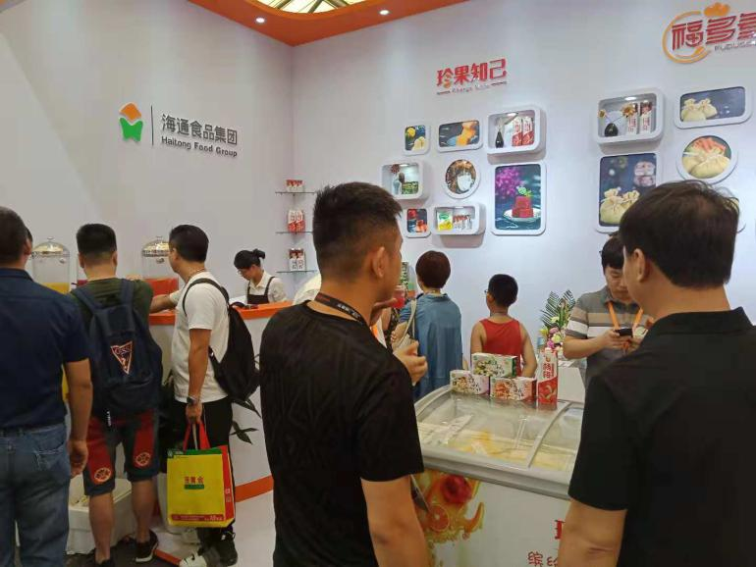

As a professional catering equipment and food and beverage trade event in East China, Exhibition attracted 2022 from Turkey, The UK, the United States, Thailand, Spain, Singapore, Russia, moldova, Malaysia, South Korea, Japan, Italy, France, Brazil, Australia, Vietnam, Taiwan, Hong Kong more than 29 countries and regions and domestic provinces and cities in 1262 exhibitors collective appearance with rich products, A total of 83,280 audiences were received, including 57,901 from professional buyers and audience, and the total area of the exhibition exceeded 80,000 ㎡. In order to meet the growing demand for high-quality food, beverages and hotel, catering in China and Asia, The 14th International Exhibition for the Food,Drink,Hotel,Catering & Foodservice Industries has a wealth of sellers, buyers and wonderful matching activities, for domestic and foreign manufacturers, distributors, retailers, experts and scholars, enthusiasts, consumers and hotel catering stakeholders can face-to-face marketing negotiations, business cooperation, experience exchange to create a most direct and effective platform, the next exhibition is expected to be larger than before, better quality!

As a leading international food catering and hotel equipment exhibition, will continue to lead brand enterprises into the Chinese market, building an important feast of international hotel and catering industry!

同期举办·Co-located

FLCE CHINA 2023上海国际生鲜配送及冷冻冷链冷库技术设备展览会

Shanghai International Fresh Logistics & Cold Chain Cold Storage Technology Equipment Exhibition 2023

**■同期活动·Concurrent Events（筹划中）：**

**2023第七届中国餐饮与冷链物流创新发展高峰论坛**

The 7th China's Catering and Cold chain Logistics Innovation Development peak BBS.

——创建中国餐饮流通新时代，将围绕“让食品流通·顺心，让食物消费·安心”展开丰富多样的主题演讲，诚邀国内外水产海鲜、肉类食品、餐饮企业、火锅产业、果蔬、乳制品、冷冻食品、农产品、餐饮设备、包装、冷链物流、冷链技术设备和连锁加盟行业人士前来一聚，以及相关协会领导和专家学者，共筑中国食材流通新时代！

本次论坛 3000 元/人（含：会议费、资料费、午餐费），交通、住宿（可推荐酒店）自理。注：11月 1 日前报名9 折优惠。（详情见附件1）

2023中国高端食品饮料论坛及新品发布会

上海团餐产品展示交流会展

上海火锅美食文化节

Shanghai Hotpot Cuisine Culture Festival

上海素食、果蔬文化节

Shanghai Vegetarian, Fruit and Vegetable Culture Festival

上海时尚饮品节

Shanghai fashion drinks Festival

咖啡拉花艺术大赛

Coffee flower art competition

中国创意菜烹饪大赛暨酒店特色食材推介会

National Creative Hotel Food Cooking Contest and Hotel Special Ingredients Event

“舌尖上的海味”水产海鲜推介品鉴会

A Bite of Seafood-Introduction and Tasting Meeting of Seafood

国际食品餐饮供应链大会

冷冻食品技术应用与市场研讨论坛

连锁商超食品采购对接会

酒店及餐饮行业采购商配对洽谈会

Hotel & Catering buyer pairing meeting

■**展品范围·Scope of exhibits：**

专业推进华东地区的餐饮、食品行业的蓬勃发展，满足酒店餐饮中高端采购的一站式需求：

展品覆盖饮料、乳制品、休闲食品、方便食品，粮油果蔬肉类食材，调味品等21大品类。

◇糖果、巧克力、乳制品、面包糕点、果汁、软饮料、罐装食品、休闲食品、冷藏食品、调味品及果酱、风干食品、冷冻食品、水果、蔬菜、绿色食品、冰淇淋、添加剂、橄榄油、意大利面制品、专用标签产品；

◇鱼、蟹、贝壳、龙虾、三文鱼、牛肉、羊肉、猪肉、家禽、清真肉、内脏制品、加工肉制品、加工海洋制品；

◇茶、糖浆、白咖啡、速溶咖啡、咖啡豆、咖啡机、烘豆机；

◇低温发酵啤酒、麦酒、黑啤酒、小麦啤酒、手工啤酒；

◇食品餐饮设备、比萨饼设备、餐具及配件、展示及储藏、冷冻 / 冷藏设备、包装材料、咖啡及饮料服务设备、面包糕点及糖果制成品、面包及糖果设备、配料 / 防腐剂 / 香精等。

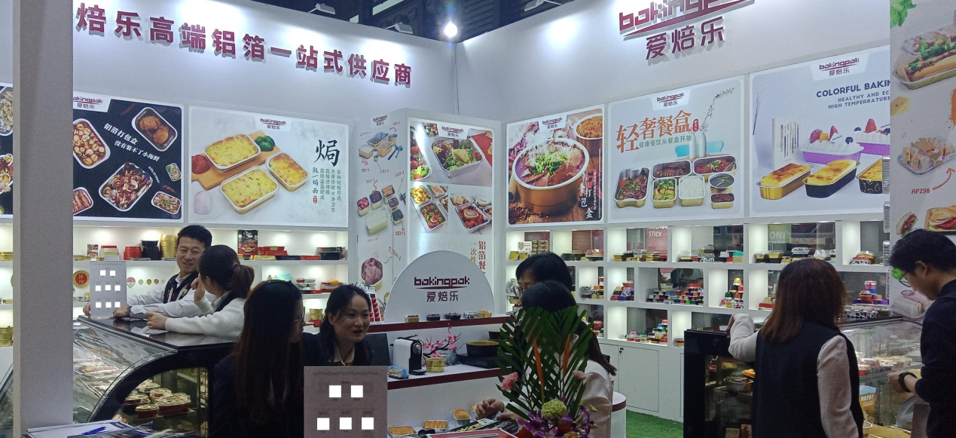

·Candies, chocolates, dairy products, bread pastries, fruit juices, soft drinks, canned foods, snack foods, refrigerated foods, condiments and jams, air-dried foods, frozen foods, fruits, vegetables, green foods, ice cream, additives, olive oil, pasta products, special label products;

·Fish、Crab、Shellfish、Lobster、Salmon、Beef、Lamb、Pork、Poultry、Halal Meat、Offal、Processed Meat、Processed Seafood;

·Tea、Syrup、White Coffee、Instant Coffee、Coffee Bean、Coffee Machine、Coffee Roaster、Accessories;

·Cold fermented beer、Pale ALE、Black beer / Stout、Wheat beer、Craft beer;

·Packaging Materials、Food Catering Equipment、Pizza Equipment、Tableware & Accessories、Display & Storage、Chilling / Freezing Equipment、Coffee & Beverage Service Equipment、Industrial Bakery & Confectionery Eq、Ingredients / Agents / Essences、Bakery & Confectionery / Finished Pr、Retail Bakery & Confectionery Equipm.

■参展费用**·Booth Rate**：

★标准展位：(注：双面开口加收10%费用)

A：国内企业：16800.00/展期（RMB） 3m×3m

B：国外企业： 4800.00/展期（USD） 3m×3m

注：标准展位（包括：三面白色壁板、中（英）文楣牌制作、咨询桌一张、折椅二张、地毯满铺、展位照明、220V/5a电源插座一个（**特殊用电请事先说明，另行收费**）、废纸篓一个。

★室内光地：

A：国内企业：1600.00（RMB）/平方米/展期

B：国外企业： 480.00（USD）/平方米/展期

注：（至少36平方米起租）“光地”只提供参展空间，不包括展架、展具、地毯、电源等。

会刊广告：◇封面 25000元 ◇封二 18000元 ◇彩首 12000元 ◇封三 15000元，◇封底 20000元 ◇彩色内页 8000元 ◇彩色内页对开 15000元；

注：会刊尺寸140mm（宽）×210mm（高）

◇参观证 50000元/3万张 ◇手提袋广告 50000元/1万个 ◇门票广告 20000元/1万张 ◇条幅广告 12000元/幅 ◇拱门 18000/个 ◇5米*3米广告牌 20000/个；

★ 新产品新技术发布会:每场10,000元/45分钟，国外企业3000.00（USD）

★ 行业特别协办单位18万，限1家；协办单位128,000，限2家；招待晚宴协办单位108,000元，限1家（详情见附件1、2、3）。**更多现场广告方案请咨询：177 6511 0324**

International Exhibitor

• Standard Booths(3m*3m): USD 4,800/9㎡;

(Plus 10% for corner booth).

• Raw Space:USD 480/㎡(minimum 36 sq.m.).

• New product and new technology conference: USD 3000/45 minutes

Industry special co organizer $32,800, only 1; CO organizer $23,800, only 2; reception dinner co organizer $20,000, limited to 1 (details see attachment 1, 2, 3).

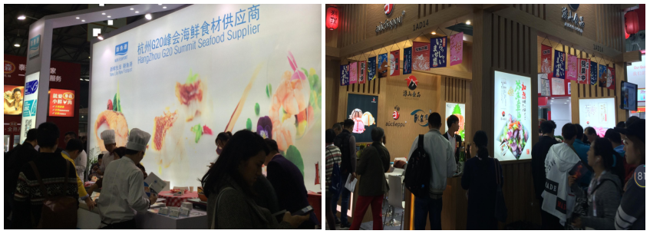

■专业观众**·** **Visiting audience**：

覆盖食品进出口商、经销商、批发与零售商、超市与综合卖场、酒店餐饮等多领域，

1、食品与饮料进口商/出口商/零售商；

2、食品与饮料制造商；

3、咖啡馆/茶馆；

4、饭店/餐馆/快餐店/小食店/外卖；

5、酒店/度假村/旅馆/酒店式住宅单位/乡村俱乐部；

6、烹饪机构；

7、酒店和餐饮服务咨询公司；

8、大型连锁企业/经销商/加盟商；

9、协会、商务团体、国企、国际公司、航空公司、银行和服务提供商等团购单位；

10、家乐福、沃尔玛、联华、农工商、好德、全家等各类超市，机场和保税区免税店。

1. Food and beverage importers/exporters/retailers;

2. Food and beverage manufacturers;

3. Cafe/teahouse;

4. Hotel/restaurants/fast-food restaurants/snack bars/takeout;

5. Hotel/resort/hotel/hotel style residential unit/country club;

6. Cooking institutions;

7. Hotel and catering service consulting company;

8. Large chain enterprises/distributors/franchisees;

9. Group buying units such as associations, business groups, state-owned enterprises, international companies, airlines, Banks and service providers;

10. Carrefour, wal-mart, lianhua, agricultural and commercial enterprises, haode, FamilyMart and other supermarkets, airports and bonded area duty-free shops.

**观众行业分析：**

**33.9%来自酒店行业；15.3%来自食品业；**

**23.4%来自餐饮行业；13.7%来自零售业；**

**8.9%来自加盟商；4.8%进出口贸易商；**

▉参展程序**·Exhibition Procedure**:

参展条件:具有《营业执照》的相关行业企业。

1.填写《参展申请表》邮寄至组织单位。展位执行 “先申请，先付款，先安排”的原则；

2.申请展位后一周内将参展费用[50%（订金）或全款]电汇或交至组织单位，余款于2023年11月1日前付清。参展商在汇出各项费用后，请将银行汇款单发邮件至展会组织单位。

1.fill in the application form for exhibition, mail to the organization. The principle of "first application, first payment, first arrangement";

2.Within one week after the Booth Application,Exhibitors will cost [50% (deposit) or full payment] by telegraphic transfer or pay to the organization ,the balance paid before in November 1, 2023. After remitting the expenses, the exhibitor will send the bank remittance email to the exhibition organization.

根据《参展商手册》安排参展事宜（宾馆、运输、搭建、展具租赁、现场翻译等）。

**FHA-China 2023第十四届上海国际餐饮设备及食品饮料博览会组委会**

Organizing Committee of The 14th Shanghai International Exhibition for

the Food,Drink,Hotel,Catering & Foodservice Industries 2023

总部：上海市浦东新区三林路235号

Add: 235 Sanlin Road,Shanghai,Pudong New Area.

**国内部**：

联系人：习经理177-6511-0324（华东）

李经理134 3988 0025（北方地区） 杨 生137 1049 1808（南方地区）

电话：86-21-6840 5229

QQ： 274402319

International Division：

Contacts: Jimmy

WeChat: 13482165724

E-mail: sales@kilnexpo.com