

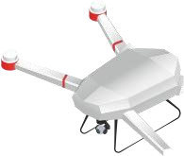r



**2025上海国际低空经济**

**与无人系统博览会**

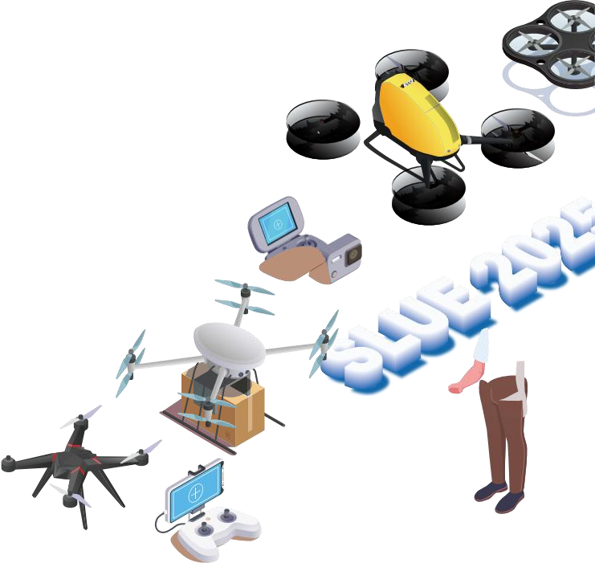Shanghai International Low-altitude Economy & UAV System Technology EXPO 2025



**2025.06.11-13**

上海新国际博览中心-中国 Shanghai New International Expo Centre-China



**指导单位 | Directed by**



上海市经济和信息化委员会

Shanghai Municipal Commission of Economy and Informatization

**批准单位 | Approved by**

上海市商务委员会

Shanghai Municipal Commission of Commerce

**主办单位 | Hosted by**

上海市航空学会

Shanghai Society of Aeronautics

**承办单位 | Organized by**

上海励贸展览服务有限公司

Shanghai L&M Exhibition Service Co.,Ltd.







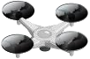

**2025.06.11-13**

上海新国际博览中心-中国 Shanghai New International Expo Centre-China

Exhibition Background



展会概况

“低空经济”是指以民用有人驾驶和无人驾驶航空器为主 ，以载人、载货及其他作业等多场景低空飞 行活动为牵引 ，辐射带动相关领域融合发展的综合性经济形态。2024年以来 ，低空经济的概念渐热 ，我国 各地进入产业发展加速期。作为新质生产力的重要代表 ，低空经济对区域经济发展贡献突出。面对这一潜 力巨大的新赛道市场 ，在相关政策扶持驱动下 ，低空经济产业有望持续快速增长。数据显示 ，到2025年 ， 中国低空经济的市场规模预计达到1.5万亿元 ，到2035年有望达到3.5万亿元。上海作为华东区域无人机产 业的发展高地 ，早在2022年9月上海市就发布《上海打造未来产业创新高地发展壮大未来产业集群行动方 案》 ，将在浦东、杨浦、闵行、金山、松江、青浦、崇明等区域 ，打造未来空间产业集群。其中 ，金山区 华东无人机基地还作为全国首批民用无人驾驶航空试验区， 占地面积5.5万平方米 ，涵盖制造、应用、材料 等各类无人机产业链 ，这都将为低空经济的快速发展提供沃土。为培育低空经济新质生产力、构建低空生 态发展新格局 ，打造中国无人机产业的发展高地。在上海市经济和信息化委员会指导下 ，经上海市商务委 员会批准， 由上海市航空学会主办 ，上海励闻展览服务有限公司具体承办的“2025上海国际低空经济与无 人系统博览会”定于2025年06月11日-13日在上海新国际博览中心召开 ，展出类别涵盖航空器研发制造、 低空飞行基础设施建设运营、飞行服务保障等各产业与应用场景等。组委会希望此活动的召开为低空经济 从业人士搭建一个专业和富有成效的产品及服务展示、商贸洽谈、技术交流的国际平台 ，助力低空经济高 质量发展。

"Low-altitude economy" refers to a comprehensive economic form that focuses on civil manned and unmanned aerial vehicles, takes multi-scenario low-altitude flight activities such as manned, cargo and other operations as the traction, and radiates the integrated development of related fields. Since 2024, the concept of low-altitude economy has become hotter, and various parts of China have entered a period of accelerated industrial development. As an important representative of new quality productivity, the low-altitude economy has made outstanding contributions to regional economic development. In the face of this new track market with huge potential, driven by relevant policy support, the low-altitude economic industry is expected to continue to grow rapidly. Data shows that by 2025, the market size of China's low-altitude economy is expected to reach 1.5 trillion yuan, and by 2035, it is expected to reach 3.5 trillion yuan.

As the development highland of the UAV industry in East China, Shanghai issued the "Action Plan for Shanghai to Build a Future Industrial Innovation Highland and Develop and Expand Future Industrial Clusters" as early as September 2022, which will build future space industrial clusters in Pudong, Yangpu, Minhang, Jinshan, Songjiang, Qingpu, Chongming and other regions. Among them, the East China UAV Base in Jinshan District is also the first batch of civil unmanned aviation test areas in the country, covering an area of 55,000 square meters, covering various UAV industry chains such as manufacturing, applications, and materials, which will provide fertile ground for the rapid development of the low-altitude economy. In order to cultivate new quality productivity of low-altitude economy, build a new pattern of low-altitude ecologi- cal development, and create a highland for the development of China's UAV industry. Under the guidance of the Shanghai Municipal Commission of Econo- my and Information Technology, approved by the Shanghai Municipal Commis- sion of Commerce, sponsored by the Shanghai Society of Aeronautics and Astronautics, and organized by Shanghai Liwen Exhibition Service Co., Ltd. the "2025 Shanghai International Low-altitude Economy and UAV system Technology Expo" is scheduled to be held at the Shanghai New International Expo Center from June 11-13, 2025. The organizing committee hopes that the convening of this event will build an international platform for low-altitude economic practitioners professional for fruitful product and service display, business negotiation and technical exchange, and promote the high-quality development of low-altitude economy.

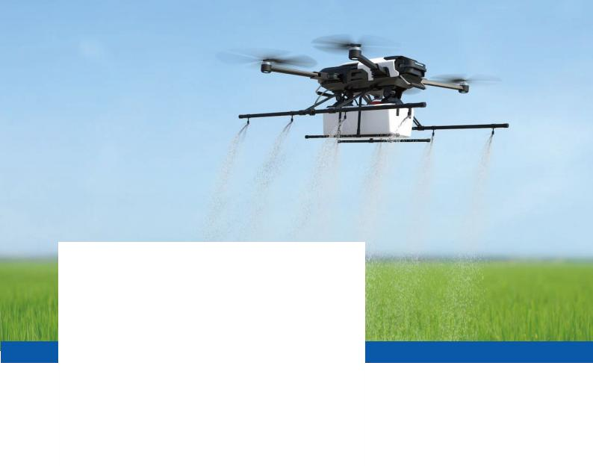**2025.06.11-13**

上海新国际博览中心-中国 Shanghai New International Expo Centre-China

Concurrent Activities



同期活动

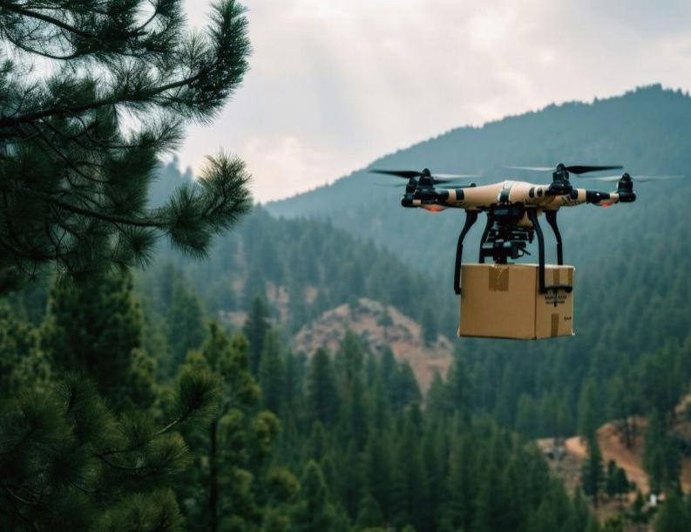展会期间将举办国际低空经济高质量发展论坛、无人机行业 高峰论坛及赛事、无人车自动驾驶与机器人论坛、国际飞行培训 研讨会等论坛活动，通过活动的举办聚焦行业前沿的高端研讨会、 现场互动的技术交流会、权威专家市场等 ，丰富的展会内容向业 内人士以及社会各界传递最新、最全的行业资讯。

During the exhibition, the International Low-altitude Economy High-quality Development Forum, UAV Industry Summit Forum and Events, Unmanned Vehicle Autonomous Driving and Robotics Forum, Internation- al Flight Training Seminar and other forum activities will be held. Combined with the cutting-edge forums, interactive technical exchange meetings, and authoritative experts, the show aims to deliver the latest and most comprehensive

SUE22 5

**2025.06.11-13**

上海新国际博览中心-中国 Shanghai New International Expo Centre-China

Major Exhibits



展出大类

 低空经济产业：通航（直升机）、无人机、eVTOL飞行器、航空材料、机载设备等。农林牧渔、低空物流、应急救援、医疗 救护、空中巡查、私人飞行、航空摄影、航空运动、飞行培训、娱乐观光（低空旅游）等；

 无人机及应用：固定翼无人机、 多旋翼无人机、垂直起降无人机、无人直升机、无人飞艇、无人伞翼机、无人潜航器等及 农林植保、警用、灾害勘查、消防救灾、应急通信、水利海事、安防监控、交通指挥、土壤检测、航空摄影、地形测量、生 产线巡检、物流运输、电力巡检无人机等；

 无人系统产业链：动力/能源/材料：发动机、发电机、电动机、螺旋桨、变速器、电池、电源及充电设备、复合材料、玻璃 钢、碳纤维、聚酰亚胺、涂层；轴承、齿轮、密封件、紧固件、线缆插座、指示灯、减震器（球）、无人机收纳盒、收纳箱 等；

。 导航/通信/控制类：遥控器和地面站、导航定位设备、自动控制系统、数传电台、图传电台、接收机、无线网桥、自组网电 台、天线、头戴显示器、传感器、自动驾驶仪、飞控软\硬件、仿真系统、测速装置、控制仿真、 舵机伺服等；

 发射/回收类：发射车、发射箱、助推器、 起落架、减震器、辅助轮、回收伞、拦阻网等；

反无人机类：反无人机枪、光电探测、扫描雷达、信号探测、手持干扰设备、导航欺骗防护站、智能网捕系统、预警管理系 统等；

 配套设备类 ：吊舱、云台、相机/摄像机、光学稳定/红外热成像设备、机载雷达、激光测距仪、报警器、喷洒系统、机器臂 系统、抗干扰系统、软件、传感器等；

 服务保障类：无人机设计、无人机驾驶员培训、软件开发商、各种无人机书刊、航空企业及高校、科研院所；飞行驾驶模拟 器、VR/AR虚拟仿真系统、在线教育培训机构及平台、APP软件、STEAM教学方案和成果、科技馆、特色学校及科普教育 基地等。

 Unmanned aerial vehicles (UAVs) and applications: fixed-wing UAVs, multi-rotor UAVs, vertical take-off and landing UAVs, unmanned helicopters, unmanned airships, unmanned paragliders, unmanned underwater vehicles, etc., as well as agricultural and forestry plant protection, police, disaster exploration, fire and disaster relief, emergency communications, water conservancy and maritime, security monitoring, traffic command, soil detection, aerial photography, topographic survey, production line inspection, logistics and transportation, power inspection UAVs, etc.

 Unmanned system industry chain: power/energy/materials: engines, generators, electric motors, propellers, transmissions, batter- ies, power supplies and charging equipment, composite materials, FRP, carbon fiber, polyimide, coatings; bearings, gears, seals, fasteners, cable sockets, indicator lights, shock absorbers (balls), drone storage boxes, storage boxes, etc.

 Navigation/communication/control: remote control and ground station, navigation and positioning equipment, automatic control system, data transmission radio, image transmission radio, receiver, wireless bridge, ad hoc network radio, antenna, head-mounted display, sensor, autopilot, flight control software and hardware, simulation system, speed measurement device, control simulation, servo, etc.

 Launch/recovery category: launch vehicle, launch box, booster, landing gear, shock absorber, training wheel, recovery umbrella, arrest net, etc.

 Anti-UAV: anti-UAV guns, photoelectric detection, scanning radar, signal detection, hand-held jamming equipment, navigation deception protection stations, intelligent net capture systems, early warning management systems, etc.

 Ancillary equipment: pods, pan-tilts, cameras/camcorders, optical stabilization/infrared thermal imaging equipment, airborne radars, laser rangefinders, alarms, spraying systems, robotic arm systems, anti-jamming systems, software, sensors, etc.

 Service guarantee: UAV design, UAV pilot training, software developers, various UAV books and periodicals, aviation enterprises, universities, and scientific research institutes; Flight driving simulator, VR/AR virtual simulation system, online education and training institutions and platforms, APP software, STEAM teaching programs and achievements, science and technology museums, characteristic schools and popular science education bases, etc.

**2025.06.11-13**

上海新国际博览中心-中国 Shanghai New International Expo Centre-China



Partic ipa

**·**

Participants



参会人员

展会期间有来自航空、航天、兵器、船舶、高校、科研院所、空军、海军、武警、气象、测绘、环保、 电力、铁路、海洋、 民政、贸易行业的代表观展参会以及数万名专业观众齐聚一堂 ，共享低空经济采购盛 会。

During the exhibition, representatives from aviation, aerospace, weapons, ships, universities, scientific research institutes, air force, navy, armed police, meteorology, surveying and mapping, environmental protection, electric power, railway, marine, civil affairs, trade industries and tens of thousands of professional visitors will gather together to share the low-altitude economic procurement event.

**2025.06.11-13**

上海新国际博览中心-中国 Shanghai New International Expo Centre-China

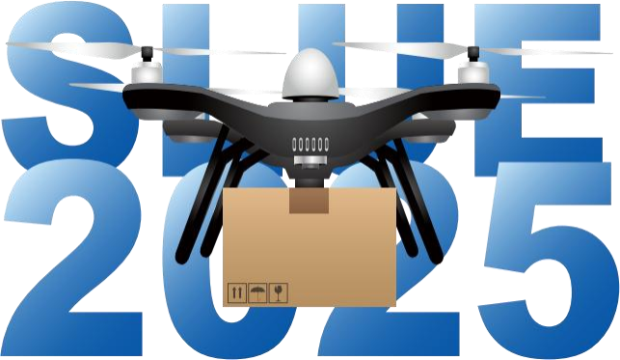



预定展位 | Booth Reservation

请立即预定“SLUE 2025”展位 ，越早预留位置越佳 ，争取最大曝光率 ，领先竞争对手 ，开拓无限商机。

Please reserve the booth of "SLUE 2025" immediately. The sooner you reserve, the better your reserved position. Strive for maximum exposure, lead competitors, and open up unlimited business opportunities.

如欲预订“SLUE 2025”采购交易会展位 ，或了解更多信息 ，请发电子邮件至: 2505783766@qq.com 。 或 通过以下联络方法 ，预订展位。

To reserve the booth of “SLUE 2025” or learn more information, please contact: 电话/ Tel :16692853591