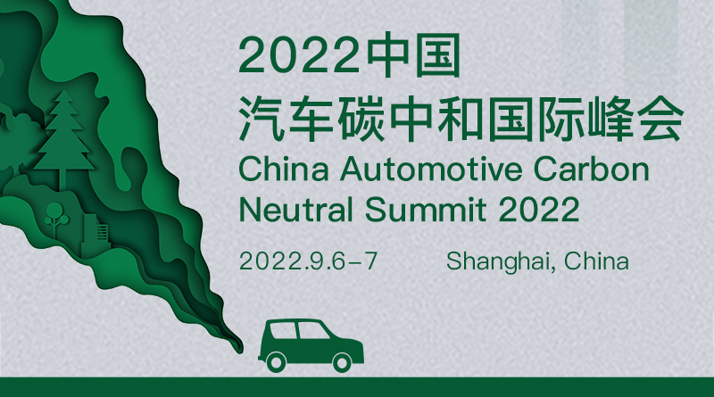2022中国汽车碳中和国际峰会
峰会背景
气候环境改变是21世纪全球最大的挑战之一，各国在政府针对日益严峻的环境问题，提出了多项环保政策。根据PwC的报告显示，在欧洲，19%的二氧化碳排放来自于汽车行业。在中国，碳达峰、碳中和的目标给各行各业带来了新考验，也提供了新机遇。汽车行业是全球温室气体排放的主要领域之一，随着我国汽车保有量不断提升，低碳环保的汽车行业发展势在必行。汽车行业实现“碳达峰、碳中和”目标，不能仅仅依靠“油改电”，需要整合产业链，选用低碳环保材料，绿色化生产制造过程，提升汽车自身能源利用有效率，使用清洁能源动力，完善汽车回收利用体系，从产品的全生命周期出发，进行管控，从而打造真正的“零碳汽车”。
2022中国汽车碳中和国际峰会，将汇集超过150位行业专家与高管，共同商讨如何在环保政策日益严苛的情况下，汽车行业如何通过各项节能减排的措施，降低整体碳排放，在计划时间内实现双碳目标，打造具有国际竞争力的低碳环保的高品质汽车。
会议时间/地点
2022年9月6日-7日 / 中国上海
会议亮点
20+家业内领先企业情报分享
100+名参会代表
与业内领军人物及前沿企业进行现场交流
线上线下同期推广，增加品牌曝光度
……
热点话题
中国碳中和政策：汽车产业发展的新要求
通过汽车电机化推进产业碳中和低碳商业模式和全产业链合作
绿色氢能制造引领新一轮能源改革
如何在汽车智能工厂实现零排放，促进汽车碳中和
清洁低碳能源网络助力汽车产业发展
……
了解更多信息请登录官网
会议官网：http://www.ecvinternational.com/AutomotiveCarbon/
联系人: Wes Wei
电话：+86 21 8026 0707-803
邮箱：marketing@ecvinternational.com
关于我们
上海希为（ECV International）是亚洲领先的国际高端商业峰会及活动的主办和承办机构，拥有近 200 位行业研究及活动策划、运营专家，每年在全球举办约 80 场高端国际峰会，涉及汽车、零售、纺织、鞋业、网络安全、高新科技等行业。
我们为超过半数的财富 2,000 强企业提供专业的商业会议及咨询服务，每年有超过 6,000 位来自戴姆勒、通用电气、阿里巴巴、西门子、微软、华为、威富集团、默克、火眼等跨国公司、专业机构及创新企业的决策人参加我们的会议和活动。
我们的使命是通过提供专业服务帮助客户抓住发展机遇、迎接挑战、实现全球范围内的可持续发展，进而影响行业格局，引领行业未来。

China Automotive Carbon Neutral Summit 2022

Summit Background
Climate and environment change is one of the greatest challenges in the 21st century. Many environmental protection policies have been put forward by governments in response to the increasingly severe environmental problems. In Europe, 19% of carbon dioxide emissions come from the automotive sector, according to PwC. In China, the target of peak carbon dioxide emissions and carbon neutrality has brought new challenges and opportunities to all walks of life. Automotive industry is one of the main fields of greenhouse gas emission in the world. With the continuous increase of automotive ownership in China, the development of low-carbon and environmental-friendly automotive industry is imperative. In order to realize the goal of "peak carbon dioxide emissions and carbon neutrality", automotive industry should not only rely on "electricity replace oil", but also integrate industrial chain, select low-carbon and environment friendly materials, use green production and manufacturing process, improve energy utilization efficiency of automotive itself, use clean energy power, perfect automotive recycling system, conduct management and control from the whole life cycle of products, so as to build a true "zero carbon automotive".
The China Automotive Carbon Neutral Summit 2022 will bring together more than 150 industry experts and executives to discuss how to reduce the overall carbon emission through various energy conservation and emission reduction measures in the automotive industry under the increasingly stringent environmental protection policies, achieve the Double Carbon Targets within the planned time, and build an internationally competitive low-carbon and environment-friendly high-quality vehicle.
Summit Time/ Address
Sep. 6-7, 2022/Shanghai, China
Highlights
China's carbon neutrality policy: New requirements for the development of automotive industry
Promote low-carbon business model of industrial carbon neutrality and whole industrial chain cooperation by automotive motorization
Green hydrogen energy manufacturing leads a new round of energy reform
How to Achieve Zero Emission in Automotive Smart Factory to Promote Automotive Carbon Neutral
Cleaning low-carbon energy network helps the development of automotive industry
……

Official website of the summit: http://www.ecvinternational.com/AutomotiveCarbon/
Contacts: Wes Wei
Phone: +86 -21 - 8026 0707 ext 803
Email: marketing@ecvinternational.com
About Us
ECV International is a leading organizer and contractor of high-end international business events in Asia, with nearly 200 professionals in industrial research and event planning & execution. We hold around 80 high-end summits every year which are involved in the fields of automotive, retail, textile, footwear, cybersecurity, hi-tech industry, etc.
We have served more than half of the Fortune 2,000 companies, and every year more than 6,000 delegates from multinational enterprises, specialized organizations and creative companies take part in our events, i.e. Daimler, Alibaba, Siemens, Microsoft, Huawei, VF Corporation, MSD, Fireeye, etc.
Our mission is to help our clients seize the development opportunity, meet current business challenges, and achieve sustainable development on a global scale through our professional services, and then, to further affect industry pattern and lead industry future.

